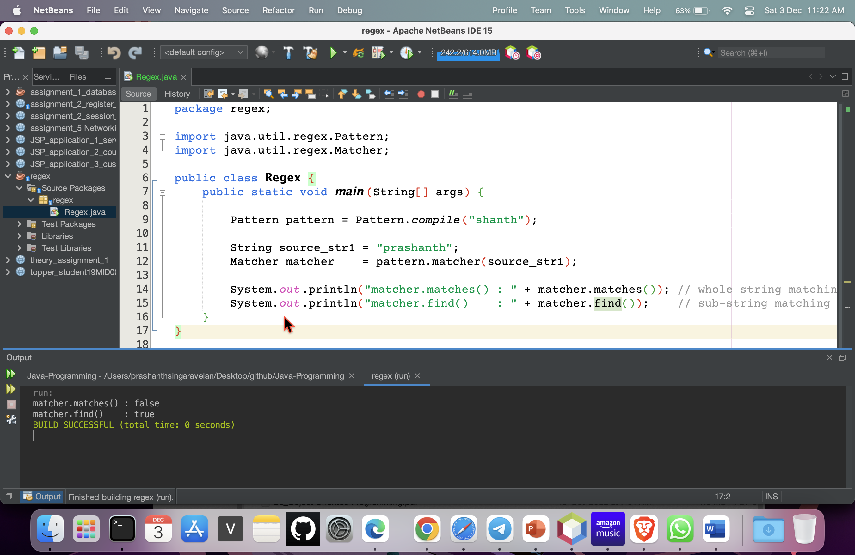

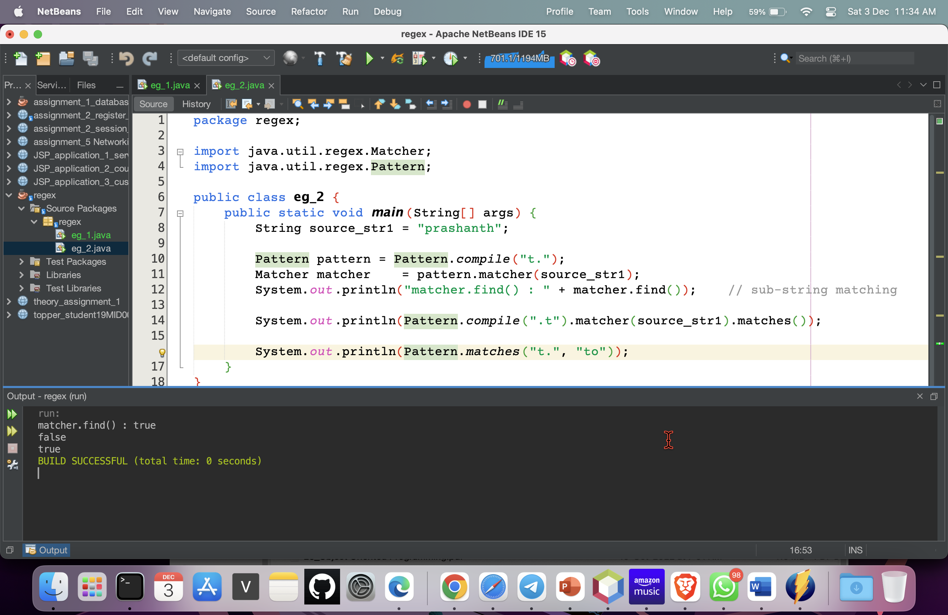

. (dot) 🡪 only a single character

.t 🡪 before t there must be 1 letter

t. 🡪 after t there must be only 1 letter

.t. 🡪 before and after t there must be only 1 letter

